Student Name: Yuyang Gong Student Number: 49079984 Team Name: FriendZone
Week: 2
Title: Planning Contextual User Research

Description:
We translated the broad topic into an interview plan focused on people living in shared accommodation and participating in local social or community groups. We prepared questions about where residents interact, what makes approaching others easier, what prevents connections from developing and what helps people stay in contact after meeting.
We deliberately asked about observed behaviour and concrete situations rather than asking participants to design an app for us. Shared kitchens, lifts, common rooms, gyms and organised activities became important contexts because they create natural opportunities for repeated contact.
Visual Evidence:
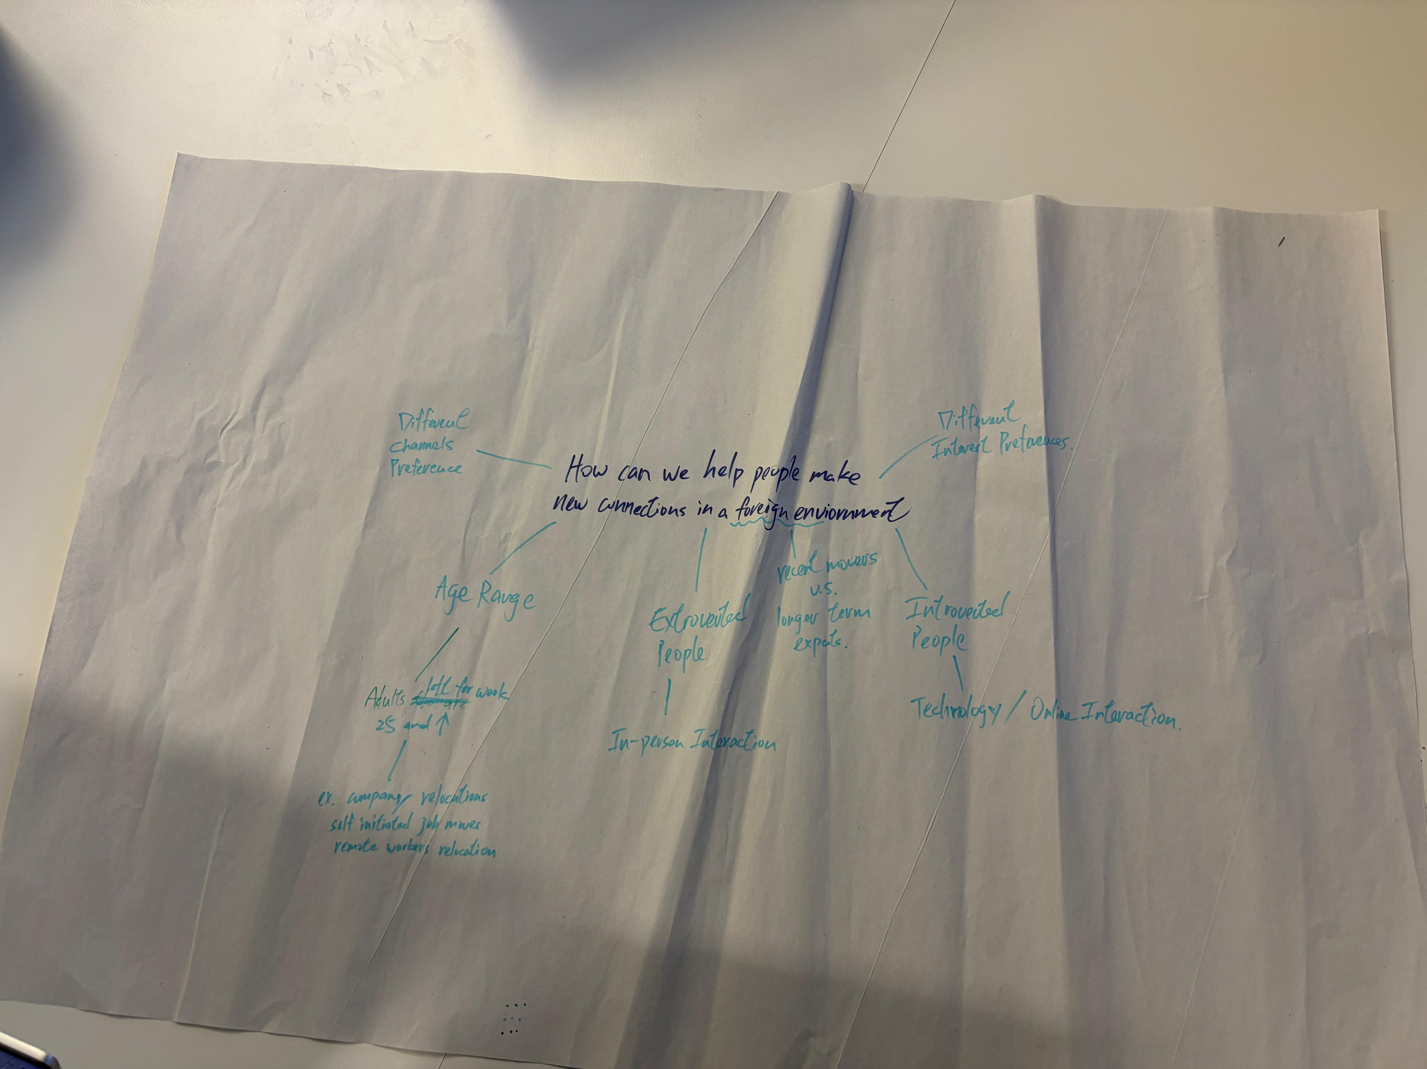
Research planning activity used to identify participants, contexts and interview topics.
Statement on Learning:
I learned that research questions should reveal behaviour, feelings and context before they test a preferred solution. Asking about real experiences helped us avoid assuming that technology alone would solve loneliness. It also gave us a clearer basis for recruiting participants and comparing patterns across interviews.

